**PROJECT REPORT**

**PROJECT NAME**: - RENTAL CAR SYSTEM.

**DEVELOPMENT**: - C Language.

**PROJECT BY**: - GOVIND Y RAVAJICHE.

## TABLE OF CONTENTS

|  |  |  |
| --- | --- | --- |
| **S No.** | **Content** | **Page No.** |
| **1.** | Introduction | **3** |
| **2.** | Objective | **4** |
| **3.** | Requirements | **5** |
| **4.** | Flow chart | **6** |
|  |  |  |
| **5.** | Input and output Display | **7** |
| **6.** | Future scope | **8** |
| **7.** | Reference | **9** |

# INTRODUCTION

This **Car Rental System Project in C**is a consoled based application created using c programming language. This system is a simple mini project and compiled in **Visual Studio** using **GCC compiler**. This shows the various automobile models from which you can select your vehicle and check its availability at any given time.

.

**Features:**

* User can view the list of cars.
* User can enter the brand of car he/she want to rent.
* The user enter the dateon which he/she will take the car.
* User enter the date on which he/she will return the car.
* Then the system will say if it is the car available or not.
* If the car is available the user will enter here name and id number.

**OBJECTIVE**

The project's goal is to automate vehicle rental and reservation so that clients don't have to waste time calling and waiting for a

vehicle. To convert the manual car rental procedure into a digital method. A customer satisfaction test was used to validate the rental

automobile system. As a system development reference, create documents such as Software Requirement Specification (SRS) and

Software Design Description.

**REQUIREMENTS**

**Software Requirement**

* Operating System: Windows 10.
* Application Software: Visual Studio
* Language : C-Programming

#### Hardware Requirements Specification

#### Processor: Intel core i3

#### Hard Disk: 250GB

#### Ram: 2GB

**FLOW CHART**

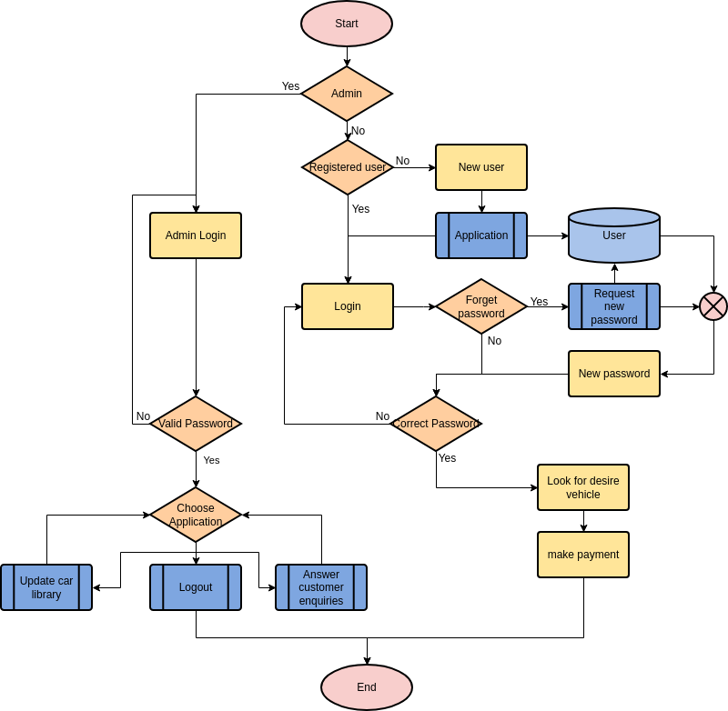

**INPUT AND OUTPUT DISPLAY**

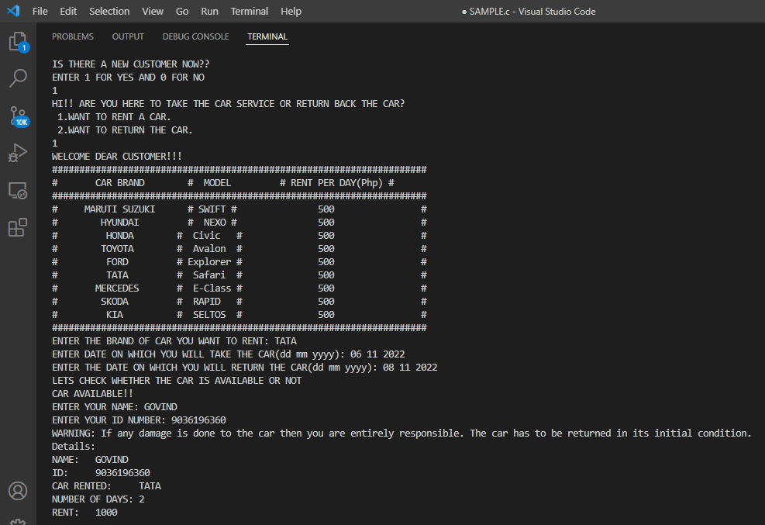

**Future Scope of Project**

This project covers a wide range of topics, from business concepts to computer science, and it necessitates the completion of

numerous studies in order to meet the project's objectives.

Some of the topics covered include:

1) Vehicle rental industry – This covers research on how the car rental industry operates, the processes involved, and the potential

for improvement.

2) The application was built using the PHP programming language.

3) Customers, as well as corporate employees, will be able to make good use of the system.

4) The web platform implies that the system will be accessible 24 hours a day, seven days a week, with the exception of minor

server outages.

**Reference**

* <https://www.codewithc.com>.
* [www.youtube.com](http://www.youtube.com).